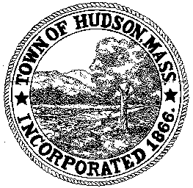

CONSERVATION COMMISSION
78 Main Street, Hudson, MA 01749
(978) 562-2020

Paul Byrne, Chairman W. Minot Wood, Vice Chairman David Esteves, Member

Terrence Joyce, Member Leif Longtine, Member Joseph Rodrigues, Member Al Tashian, Member

Meeting Agenda
February 2, 2012 7:00 P.M.

- Preliminaries
  - Open Meeting
  - Roll Call

2.0 New Business
2.1 DEP 190-0560
Applicant: Town of Hudson DPW
Location: Brook Street
Project Description: Installation of a drain pipe network within the existing traveled way. Drain pipe, catch basins and manholes will be constructed. Construction will involve trenching within the roadway, placement of pipes and structures, and backfill. Upon completion of the drain installations, a full pavement overlay with bituminous curbs is proposed. During construction, the trenches will be backfilled immediately after completion, and temporary pavement will be placed as quickly as practicable. The construction is expected to be completed within approximately 2 to 6 months.

2.2 Community Garden

2.3 Request for Review and Comments
511 Coolidge Street

2.4 Minutes – January 19, 2012

3.0 Old Business

4.0 Correspondence

5.0 Executive Session
To discuss pending litigation and potential further enforcement action, the public discussion of which may impair the proceedings.

5.0 Adjournment

Next Meeting: February 16, 2012

